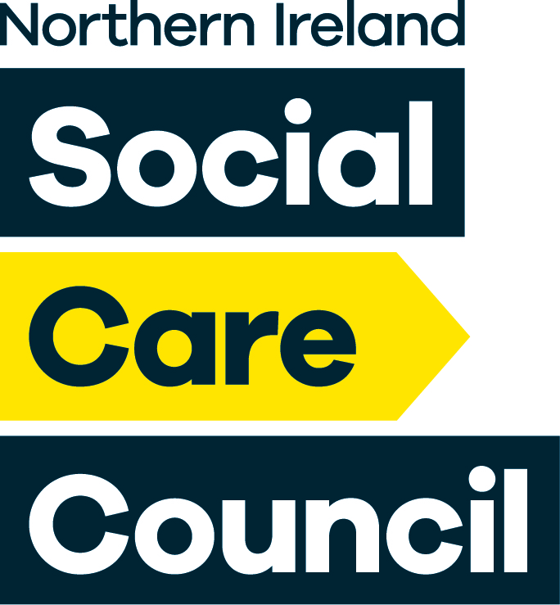
Certificate of Completion of AYE

(Form Ref AYE1)

It is the responsibility of the registrant to ensure this form is completed and returned to the Northern Ireland Social Care Council within one year of commencing the AYE. Failure to do so may result in removal from the Register. Registrants who require additional time to complete the AYE should apply for an extension using the Northern Ireland Social Care Council ‘Application for Extension’ (Form reference AYE2).

Registrant name as appears on Northern Ireland Social Care Council Register:

Registration number:

Employing organisation:

Employment sector:

Workplace address: Postcode:

Contact details: Phone:
Email:

Line Manager/Supervising social worker name as appears on Northern Ireland Social Care Council Register (please underline applicable designation):

Line Manager/Supervising social worker Registration number:

Date Registrant commenced the AYE:

Date Registrant will complete the AYE:
(This will be one calendar year from the date of commencement unless an extension was agreed)

(Form ref AYE1-V3-2022) (Page 1 of 2)
Employer Declaration

The registrant has successfully completed the AYE and the Northern Ireland Social Care Council AYE Standards have been met.

Registrant Details  Name (Please Print):…………………………………………………..  Registrant signature:………………………………………………… | Date:..………
Line Manager Details  Name (Please Print):……………………………………………………  Line manager signature: ………………………………………………  Supervising social worker signature (if not Line Manager):  Name (Please Print):……………………………………………………  Signature:…………………………………………………………………  Tel No:………………………………….Email:…………………………. | Date:..………  Date:..………
Employer signatory  Name (Please Print):……………………………………………………  Position in the Organisation:………………………………………….  Signature:…………………………………………………………………  Tel No:………………………………….Email:…………………………. | Date:..………

(Form ref AYE1- V3- 2022) (Page 2 of 2)

This form should be signed by a senior manager who has been designated by their organisation. Organisations employing newly qualified social workers must nominate a designated person/s to confirm completion of the AYE and must provide the Northern Ireland Social Care Council with sample signatures (see Proforma AYE 5). The designated person should understand the standards a newly qualified social worker is expected to meet and be in a position to satisfy him/herself that these standards have been met.

